

A MINI PROJECT REPORT

on
WEB DESIGN TECHNOLOGIES (24CSE361)
FITNESS TRACKER DASHBOARD

Submitted by
MANYASHREE C R

1NH24CS123

Under the guidance of

Ms DIVYANSHI CHHABRA

ASSISTANT PROFESSOR

In partial fulfillment for the award of the degree of

BACHELOR OF ENGINEERING
in
COMPUTER SCIENCE AND ENGINEERING
Academic Year: 2025-26 (ODD SEM)

CERTIFICATE

This is to certify that the mini project work titled “Fitness Tracker Dashboard” is a bonafide work carried out by Manyashree C R (1NH24CS123) in partial fulfillment of the degree of Bachelor of Engineering in Computer Science and Engineering of the New Horizon College of Engineering during the year 2025-2026.

Signature of Guide Signature of HOD

SEMESTER END EXAMINATION

Name of the Examiner Signature with date

1.

2.

ABSTRACT

The Fitness Tracker Dashboard is a web-based application designed to help users monitor, record, and analyze their daily fitness activities in an organized and user-friendly manner. This system provides a centralized platform where users can log essential workout metrics such as plank duration, push-ups, crunches, sit-ups, and running distance. The dashboard also includes a personalized profile module that stores user details like name, email, date of birth, age, and hobbies, enabling a customized user experience.

The primary objective of the project is to promote health awareness by offering an intuitive interface that visually represents progress and motivates consistent fitness habits. Features such as data visualization, daily activity tracking, and secure login ensure both usability and privacy. By integrating HTML, CSS, and JavaScript, the system provides a responsive and interactive environment suitable for users aiming to maintain or improve their physical well-being. Overall, the Fitness Tracker Dashboard serves as an efficient tool for self-assessment and long-term fitness management.

ACKNOWLEDGEMENT
The satisfaction and euphoria that accompany the successful completion of any task would be impossible without the mention of the people who made it possible, who’s constant guidance and encouragement crowned our efforts with success.

I have great pleasure in expressing gratitude to Dr. Mohan Manghnani, Chairman, New Horizon Educational Institutions, for providing necessary infrastructure and creating good environment.

I take this opportunity to express my profound gratitude to Dr. Manjunatha, Principal, New Horizon College of Engineering, for the constant support and encouragement.

I would like to thank Dr. Anandhi R J, Professor and Dean-Academics, NHCE, for her valuable guidance.

I would also like to thank Dr. B. Rajalakshmi, Professor and HOD, Department of Computer Science and Engineering, for the constant support.

I also express my gratitude to Ms Divyanshi Chhabra, Department of Computer Science and Engineering, my mini project reviewer, for constantly monitoring the development of the project and setting up precise deadlines. Her valuable suggestions were the motivating factors in completing the work.

CONTENTS | Manyashree C R  1NH24CS123
ABSTRACT |  | I
ACKNOWLEDGEMENT |  | II
CONTENTS |  | III
LIST OF FIGURES |  | V
- INTRODUCTION |  | 1
1.1 PROBLEM DEFINITION |  | 1
- OBJECTIVES |  | 2
1.3 METHODOLOGIES TO BE FOLLOWED |  | 3
- FUNDAMENTALS OF THE LANGUAGES USED |  | 4
2.1 HTML |  | 4
2.2 HTML TAGS |  | 6
2.3 CSS |  | 6
2.4 JAVASCRIPTS |  | 7
2.5 XHTML |  | 8
2.6 XML |  | 9
- REQUIREMENT SPECIFICATION |  | 11
3.1 HARDWARE REQUIREMENTS |  | 11
3.2 SOFTWARE REQUIREMENTS |  | 11
- DESIGN |  | 12
4.1 DESIGN GOALS |  | 12
- IMPLEMENTATION |  | 13
5.1 HOME PAGE |  | 13
5.2 PROFILE PAGE |  | 15

5.3 | SIGNUP AND LOGIN PAGE | 16
- RESULTS |  | 17
6.1 | MAIN PAGE | 17
6.2 | PROFILE PAGE | 19
6.3 | SIGNUP AND LOGIN PAGE | 20
- CONCLUSION |  | 20
REFERENCES 21

LIST OF FIGURES

Figure No. | Description | Page No.
1 | Introduction | 1-3
2 | Fundamentals of the languages | 4-9
3 | Requirement Specification | 10
4 | Design | 11-13
5 | Implimentation | 14-18
6 | Result | 19-25
7 | Conclusion | 26-28
8 | Resources | 29

LIST OF TABLES

Table No. | Description | Page No.
1 | HTML Tags | 5

CHAPTER 1

INTRODUCTION

PROBLEM DEFINITION

A Fitness Tracking Dashboard is a simple, user-friendly, and modern web application that enables users to log their daily exercises such as running, cycling, sit-ups, planks, push-ups, and squats. It serves as a personal virtual fitness diary that stores everyday workout data and displays progress in a visually engaging manner.

In today’s busy lifestyle, people struggle to maintain consistent f itness habits and track their health activities efficiently. Most tracking tools are either too complex or require multiple apps. This project aims to create a simple, interactive, and visually engaging fitness tracking dashboard where users can log workouts, check calorie burns, and visualize their progress in one place.

The problem can be summarized as follows:

• Users lack a centralized platform to record daily fitness activities such as sit-ups, push-ups, squats, planks, running distance, and calories burned.

• Most available fitness trackers require wearable devices or accounts, which may not be affordable or necessary for simple tracking.

• There is no straightforward solution for beginners who want a basic interface to log daily workouts without distractions.

• Users need a way to visually monitor progress through charts, statistics, and logs to stay motivated.

• There is a need for a dashboard where users can save their entries daily and retrieve them later for long-term analysis.

OBJECTIVES

The objectives of this project are:

Primary Objectives

1. To create an easy-to-use fitness dashboard using HTML, CSS, and JavaScript.

2. To enable users to manually enter daily workout achievements such as:

    - Pushups
    - Sit-ups
    - Squats
    - Crunches
    - Plank time
    - Running distance in kilometers
    - Steps walked

3. To store each day’s progress for future comparison and analysis.

Secondary Objectives

4. To design the interface in a way that motivates the user to maintain consistency.

5. To visualize data using appealing UI elements like tables, cards, or charts.

6. To provide a safe and simple method for saving progress using local storage or JSON objects.

7. To implement a responsive layout that works on desktops, laptops, and phones.

8. To allow users to view, edit, or delete past workout entries.

METHODOLOGIES TO BE FOLLOWED

Requirement Analysis

• Identify the types of workouts users want to track.
• Understand user flow: Login → Dashboard → Enter Data → Save → View Progress.

Design Phase

• Create sketches for homepage, login page, dashboard, and progress page.
• Decide layout using Flexbox/Grid.
• Choose a color palette (green/blue for fitness themes).

Front-End Development

• Build structure with HTML5 semantic tags:
<header>,<nav>,<main>,<section>,<article>,<footer>.
• Style using CSS3 features like:
    - Flexbox
    - Grid
    - Transitions / animations
    - Media Queries for responsiveness

JavaScript Functionality

• Implement input validation.
• Save data using LocalStorage.
• Display saved data dynamically.
• Create motivational messages based on performance.
• Generate daily summary.

Testing

• Browser compatibility
• Responsiveness
• Error handling in input fields

Documentation

• Prepare report covering all chapters as per mini-project format.
CHAPTER 2

FUNDAMENTALS OF THE LANGUAGES USED

HTML

HTML is the main structure-building language used in your Fitness Tracker Dashboard.

It defines the layout, elements, sections, and content seen on the browser.

How HTML is used in this project:

To create Login Page, Profile Form, and Main Dashboard

To build input fields like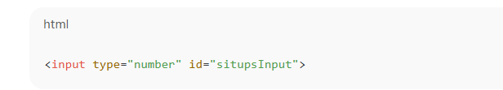

To create buttons for actions such as Login, Save Progress, Logout, etc.

To divide the webpage into sections using <div>, <header>, <h1>, <p> etc.

Examples from code:

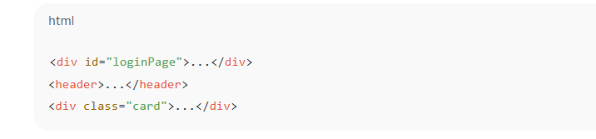

2.3 HTML TAGS

Tag Name | Purpose / Description
<DOCTYPE html> | Declares the document type as HTML5
<html> | Root element of the webpage.
<head> | Contains metadata,title,styles,scripts.
<meta> | Defines character set and viewport settings.
<title> | Sets the webpage title
<style> | Contains internal CSS for styling the website.
<body> | Contains all visible content on the webpage.
<header> | Displays the top heading section of the dashboard.
<h1> | Main heading element for titles.
<p> | Represents paragraphs or small text notes.
<div> | Main container tag for grouping content sections.
<input> | Used for text,number,date,email,and password entry.
<label> | Displays labels for input fields.
<button> | Used for Login,save,Logout, and Profile actions.
<script> | Contains all JavaScript logic for functionality.
<strong> | Makes text bold(used in daily progress logs).
<br> | Inserts a line break inside progress entries.

CSS

In the Fitness Tracker Dashboard project, CSS is used for:

Setting backgrounds, fonts, colors

Designing cards, forms, buttons

Creating grid layouts for fitness progress

Styling the login page, home page, and profile page

Making navigation menus clean and clickable

Improving user experience with hover effects

This helps convert plain HTML content into a professional-looking fitness dashboard.

CSS (Cascading Style Sheets) is used in the Fitness Tracker Dashboard to design, style, and visually organize all the web pages, making the interface attractive, user-friendly, and structured.

In this project, CSS is applied using internal styling within the <style> tag to control

layout, colors, spacing, and overall appearance of the dashboard. Various CSS selectors such as element selectors (body, input, button), class selectors (.container, .login-box, .dashboard-grid, .dashboard-card, .profile-section), and pseudo-classes (button:hover, .nav-links a:hover) are used to style specific parts of the page. CSS helps in formatting the login page, navigation links, profile section, and fitness progress cards using

properties like background-color, padding, margin, border-radius, box-shadow, font-size, and display: grid. The grid layout is used to neatly arrange the fitness tracking cards, while the box model properties help create clean, spaced-out, and well-shaped sections. Hover effects improve user interaction, and form elements like labels, inputs, and buttons are styled to look clean and professional. Overall, CSS plays a crucial role in enhancing the dashboard’s visual presentation by separating design from content, making the

website responsive, modern, and easy to use.

JAVASCRIPT

JavaScript is the programming language used in the Fitness Tracker Dashboard to make the website
dynamic, interactive, and functional. While HTML provides the structure and CSS provides design,
JavaScript adds the actual behavior that allows users to interact with the fitness tracking system.

In the given code, JavaScript is mainly used to handle login validation, navigation between different
Sections (Home, Profile, Dashboard), updating fitness progress, and displaying user information on
the screen.
- JavaScript controls the visibility of different pages using functions such as showPage()
that hide and show HTML elements based on user actions.
- It also stores user details and fitness activity data temporarily using variables and updates these values whenever the user enters plank time,pushups, crunches, sit-ups, or running distance.
- Event listeners are used to capture button clicks,such as when the user logs in, updates progress, or saves profile information.
- JavaScript immediately updates the related sections in the dashboard.
- DOM manipulation methods like document.getElementById() and innerHTML are used to insert updated values into cards and tables dynamically without reloading the page.

In this way, JavaScript acts as the logical engine of the website,ensuring smooth navigation, live updates, real-time interaction, and a responsive user experience.

Overall,JavaScript plays a crucial role in converting a static fitness website into a completely
functional dashboard that tracks activities and displays progress instantly.

XHTML

- XHTML stands for Extensible HyperText Markup Language.
- It is a stricter and cleaner version of HTML.
- XHTML is based on XML, which means it follows strict syntax rules.
- All tags in XHTML must be properly closed (example: <br />, <img />).
- Tags and attributes must be written in lowercase only.
- All attributes must have quotation marks around values (example: type="text").
- XHTML requires well-formed code, meaning no missing closing tags or mismatched nesting.
- It is designed to be more consistent and compatible across devices.
- Helps in creating websites that work better on mobile devices, screen readers, and XML-based systems.
- XHTML documents must start with a proper DOCTYPE declaration.
- It improves error detection, as browsers do not allow sloppy coding.
- XHTML encourages clean coding practices, making maintenance easier.
- It supports extensibility, meaning new tags can be added using XML rules.
- XHTML files are usually saved with the extension .xhtml.
- It was created to replace older versions of HTML but later HTML5 became more popular because it is less strict.

XML

XML stands for Extensible Markup Language.

- XML is used to store, structure, and transport data, not to display it.
- It is a self-descriptive language, meaning data is wrapped inside meaningful tags.
- XML allows users to create their own custom tags, unlike HTML.
- XML follows strict syntax rules, similar to XHTML.
- All XML tags must be properly opened and closed.
- Tag names are case-sensitive (<Name> is different from <name>).
- All attribute values must be enclosed in quotes.
- XML documents must be well-formed, meaning correct nesting, closing tags, and structure.
- XML is platform-independent, making it easy to share data across different systems.
- It is widely used for data exchange between applications (e.g., web services, APIs).
- XML is the backbone of many technologies like SOAP, RSS feeds, SVG, etc.
- It supports Unicode, meaning it can store information in any language.
- XML does not define how data looks—it only defines what the data is.
- XML can be validated using DTD or XML Schema to ensure the structure is correct.
- XML files are usually saved with the extension .xml.

CHAPTER 3

REQUIREMENT SPECIFICATION

HARDWARE REQUIREMENTS
• Processor: Intel Core i3 / AMD equivalent — needed for running browsers, IDEs, and debugging tools.
• RAM: Minimum 4 GB (8 GB recommended) — ensures smooth coding, live preview, and multitasking.
• Storage: At least 2 GB free space — for project files, images, and assets; SSD preferred for faster performance.
• Display: 1280×720 or higher — necessary for testing responsive layouts properly.

SOFTWARE REQUIREMENTS

- Operating System: Windows 10/11, macOS, or Linux — all support web development tools.

- Code Editor: VS Code (recommended); alternatives include Sublime Text, Atom, Notepad++, Brackets.

- Browsers: Chrome 90+, Firefox 80+, or Edge 90+ — used to test responsiveness and cross-browser compatibility.

- Languages & Tools:

    - HTML5 – structure of the website
    - CSS3 – styling and layout
    - JavaScript – functionality and logic
    - JSON / LocalStorage – storing user progress data
    - (Optional) Chart.js – for visual progress graphs

CHAPTER 4

DESIGN

The design phase is one of the most critical stages in software development. It acts as a blueprint for the entire implementation. In this project, design includes the layout design, UI design, data flow, system architecture, workflow diagrams, and navigation structure. A well-planned design ensures the application is user-friendly, responsive, visually appealing, and efficient.

4.1 DESIGN GOALS

The primary purpose of designing the Fitness Tracking Dashboard is to create a smooth and motivating experience for users who want to track their daily workout progress.

The design must achieve the following goals:

  - User-Friendliness

o All features should be easy to locate and use.
o The dashboard should not overwhelm the user with too many options.

  - Clarity of Information

o Daily workout entries, totals, and history should be displayed clearly.
o Icons and colors must be used to differentiate workouts visually.

  - Motivational Interface

o Fitness apps rely heavily on motivation.
o Colors, quotes, and progress elements encourage users daily.

  - Responsiveness

o Users may access the dashboard from mobile, tablet, laptop.
o Layout must adjust automatically using CSS Grid/Flexbox.

  - Data Organization

o Workout entries must be structured in an easy-to-read table or card format.
o User profile and BMI information should be separate.

  - Performance & Light Weight

o Site should load quickly.
o Use optimized fonts, images, and

CHAPTER 5

IMPLEMENTATION

5.1 HTML Implementation

5.1.1 Login Page

The login page is the first screen the user interacts with.
It contains:
- Username field (<input type="text">)
- Password field (<input type="password">)
- Login button (<button onclick="login()">)
This section is wrapped inside:
<div id="login-page"> ... </div>

Purpose:

- To authenticate the user input (not connected to a backend).
- To hide the dashboard until the login form is filled.

5.1.2 Dashboard

After successful login, the dashboard becomes visible.
It contains:

A. Navigation Bar
Navigation buttons allow switching between three pages:
- Home
- Daily Progress
- Profile
Each button calls the showPage() JavaScript function.

<nav>
<button onclick="showPage('home-page')">Home</button>
<button onclick="showPage('progress-page')">Daily Progress</button>
<button onclick="showPage('profile-page')">Profile</button>
</nav>

5.1.3 Home Page

Static welcome section:

<section id="home-page"> ... </section>

This page displays a greeting message and introduces the purpose of the dashboard.

5.1.4 Daily Progress Page

This page contains multiple <input type="number"> fields for recording fitness activity:

- Plank Duration
- Pushups
- Crunches
- Situps
- Running Distance

A button triggers saveProgress().

<button onclick="saveProgress()">Save Progress</button>

The success message displays in:

<p id="progress-msg"></p>

5.1.5 Profile Page

Contains a profile form with fields:
- Full Name
- Email
- Date of Birth
- Age
- Hobbies

After clicking Save Profile, saveProfile() shows a message.

5.2 CSS Implementation

5.2.1 Global Body Style

body {
margin: 0;
background: #f3f3f3;
font-family: Arial;
}

Ensures a clean user-friendly appearance.

5.2.2 Login Page Styling

The login page is centered both vertically & horizontally using Flexbox

#login-page {
display: flex;
justify-content: center;
align-items: center;
background: #222;
}

The login box has:
- Dark theme background
- Styled inputs
- Vibrant green login button

5.2.3 Navigation Bar

Navigation uses a dark theme for consistency:

nav {
background: #222;
padding: 15px;
display: flex;
justify-content: space-around;
}

Buttons are styled in green for visibility and branding
.

5.2.4 Page Form Inputs

The inputs on the Profile and Progress pages have:

- Padding
- Margin spacing
- Rounded borders
This ensures a clean form layout.

5.2.5 .hidden Utility Class

A simple but powerful class:

.hidden { display: none; }

Used to show/hide pages dynamically using JavaScript.

5.3 JavaScript Implementation

5.3.1 Login Function

function login() {
let user = document.getElementById('username').value;
let pass = document.getElementById('password').value;

if (user.trim() !== '' && pass.trim() !== '') {
document.getElementById('login-page').classList.add('hidden');
document.getElementById('dashboard').classList.remove('hidden');
} else {
alert("Enter valid details!");
}
}

Purpose:
- Ensures both inputs are not empty.
- Hides the login page.
- Displays the dashboard.

5.3.2 Page Navigation

The navigation buttons call showPage(page):
function showPage(page) {
document.getElementById('home-page').classList.add('hidden');
document.getElementById('progress-page').classList.add('hidden');
document.getElementById('profile-page').classList.add('hidden');

document.getElementById(page).classList.remove('hidden');
}
Purpose:
- Hides all pages.
- Shows the requested page.
- Achieves single-page-application (SPA) behavior without frameworks.

5.3.3 Save Progress

function saveProgress() {
document.getElementById('progress-msg').innerText =
"Progress Recorded Successfully!";
}
Purpose:
- Provides feedback upon saving.
- In real applications, data would be saved to a backend or local storage.

5.3.4 Save Profile

function saveProfile() {
document.getElementById('profile-msg').innerText =
"Profile Updated Successfully!";
}
Purpose:
- Confirms profile update.
- Same as progress, real apps may save to a database.

Technologies Used
Component | Technology
Structure | HTML5
Styling | CSS3
Interactivity | JavaScript
Application Type | Front-end Single-Page Application (manual SPA)

CHAPTER 6

RESULTS

6.1 Login Page

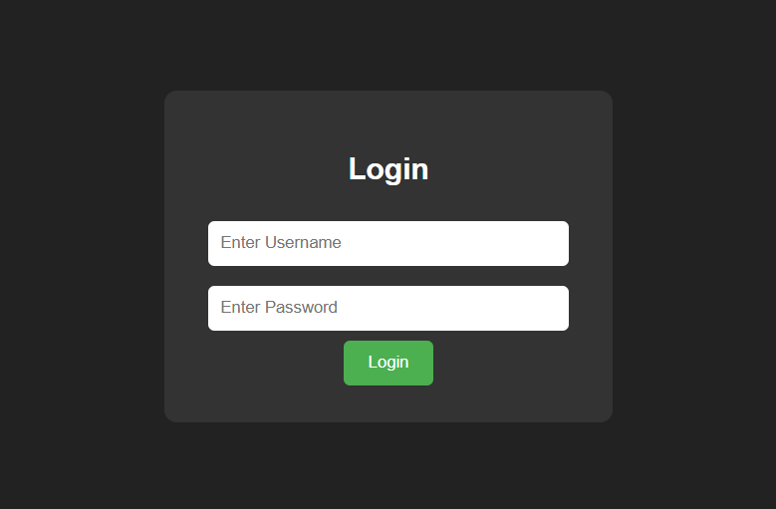

- This page allows the user to enter their username and password to securely access the fitness tracker system.

- Only valid login credentials will let the user proceed to their personalized dashboard, ensuring data privacy.

6.2 Home Page

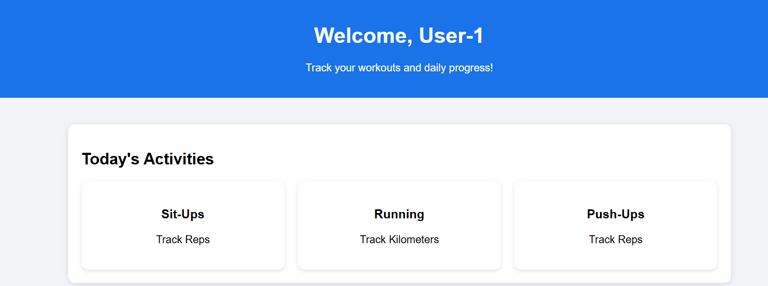

- Welcome & Overview:
Displays a personalized greeting (e.g., “Welcome, User-1”) and gives the user an overview message about their fitness tracking.

- Quick Activity Options:
Shows activity tiles (Sit-Ups, Running, Push-Ups) allowing the user to navigate to different workout areas quickly.

RESULTS

6.3 Profile Page

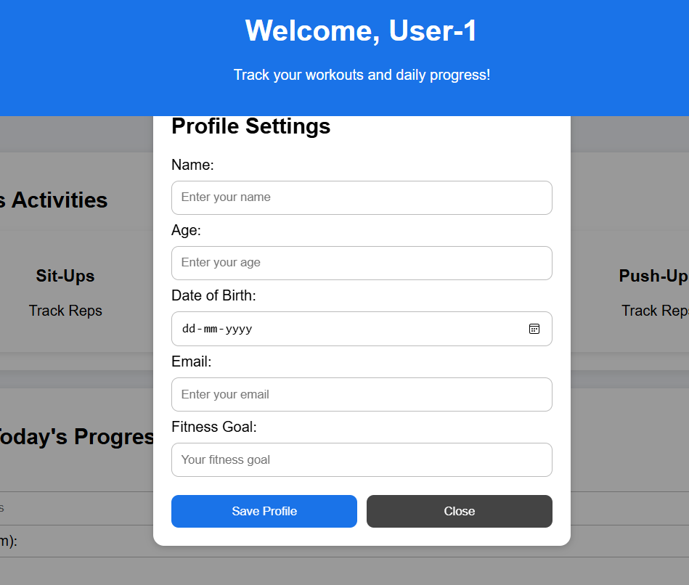

- User Information Management:
This page lets the user enter or update personal details such as name, age, date of birth, email, and fitness goals.

- Profile Saving:
Provides options like Save Profile and Close, allowing users to store updated details or exit the page without changes.

6.4 Entry Page

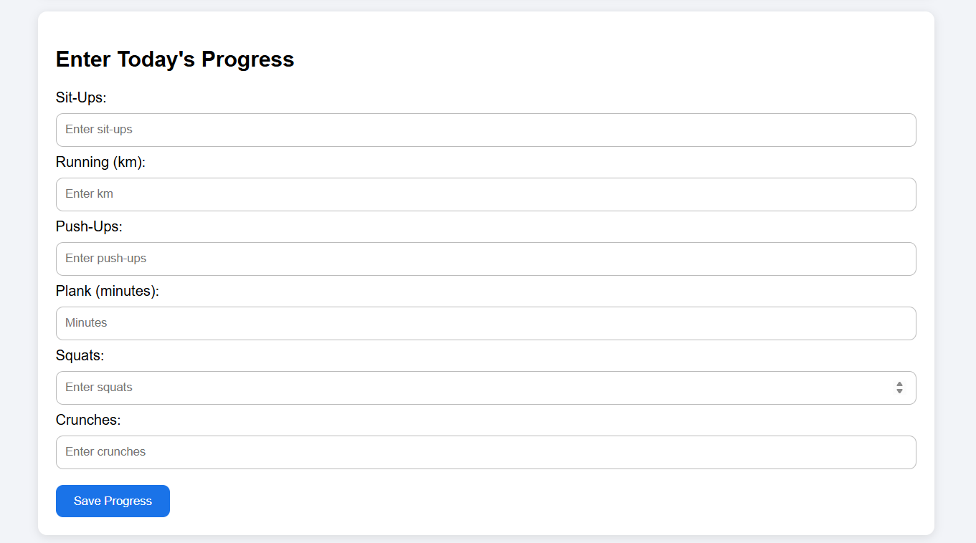

- Daily Workout Input:
Users can record their daily progress for multiple exercises such as sit-ups, running (km), push-ups, squats, and crunches.

- Progress Tracking:
The Save Progress button stores the entered activity data, which will contribute to the user’s daily/weekly performance tracking.

6.5 Saved Progress

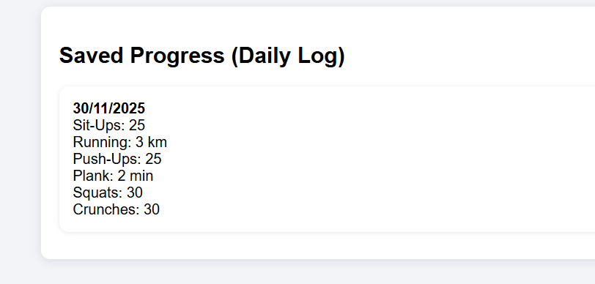

- Displays Recorded Workout Data:
This section shows a summary of the user’s daily fitness activities, including sit-ups, running distance, push-ups, planking time, squats, and crunches for a specific date.

- Progress Monitoring:
It allows the user to review their saved workout entries, helping them track improvement and maintain consistency over time.

6.6 Log Out Button



- Quick Navigation Access:
The Profile button lets users quickly open their personal information page to view or edit their details.

- Secure Exit Option:
The Logout button provides a safe way for users to sign out of their account, ensuring their data remains protected after use.

CHAPTER 7

CONCLUSION

- Well-Structured Codebase:
The project uses clearly separated HTML, CSS, and JavaScript sections, making the code easy to read and maintain.

- Simple Login Interface:
The login form creates a basic user entry point and can be expanded into a full authentication system later.

- Smooth Page Navigation:
Content switching is handled by adding or removing the hidden class, giving the dashboard a single-page application feel.

- User-Friendly Layout:
The interface is intuitive, with clear buttons and sections that guide users easily through different dashboard features.

- Functional Daily Progress Tracking:
Inputs for plank time, pushups, crunches, sit-ups, and running allow users to manually record their fitness activity.

- Profile Management Capability:
The profile page allows users to enter essential personal information, enabling future personalization.

- Real-Time Feedback:
Confirmation messages appear immediately after saving progress or updating profiles, improving user experience.

- Minimalist Visual Design:
The clean and simple design ensures focus on functionality while remaining aesthetically pleasing.

- Clear UI Separation:
Each page—Home, Daily Progress, Profile—is isolated using sections, making future enhancements easier.

- No External Libraries Required:
The dashboard functions entirely with vanilla HTML, CSS, and JavaScript, which is ideal for beginners.

- High Expandability:
The structure allows easy integration of features like charts, logs, calendar tracking, or achievements.

- Responsive Foundation:
Basic responsive elements are included, and additional adjustments can turn it into a fully mobile-friendly app.

- Good Learning Project:
This dashboard teaches essential web development concepts such as DOM manipulation, event handling, and UI design.

- Potential for Data Storage:
The system currently displays messages only, but can easily be upgraded to use localStorage, a database, or an API.

- Strong Base for a Full Fitness App:
The dashboard acts as a solid starting point for building a complete, professional fitness tracking application with more advanced features.

REFERENCES

- MDN Web Docs – HTML Elements Reference
https://developer.mozilla.org/en-US/docs/Web/HTML/Element

- MDN Web Docs – CSS Reference
https://developer.mozilla.org/en-US/docs/Web/CSS/Reference

- MDN Web Docs – JavaScript Guide (DOM Manipulation)
https://developer.mozilla.org/en-US/docs/Web/API/Document_Object_Model/Introduction

- W3Schools – HTML, CSS, and JavaScript Tutorials
https://www.w3schools.com/

- Google Developers – Web Fundamentals (UI/UX Best Practices)
https://developers.google.com/web/fundamentals

- FreeCodeCamp – Responsive Web Design Curriculum
https://www.freecodecamp.org/learn/responsive-web-design/

- Stack Overflow – Developer Community for Troubleshooting
https://stackoverflow.com/

